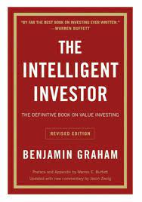Financial Books

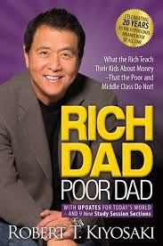

Book Name: The intelligent Investor Book Name: Rich dad Poor dad

Book Author: Benjamin Graham Book Author: Robert Kiyosaki

Genre: Financial Literacy Genre: Financial Literacy

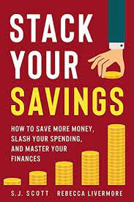

Book Name: Stack your savings

how to save money, slash your spending,

and master your finances

Book Author: S.J. Scott Livermore

Genre: Financial Literacy

Psychological Books

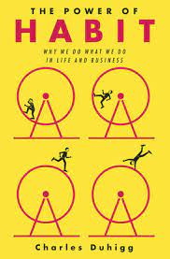 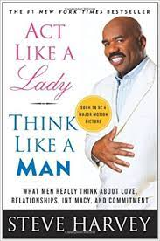

Book Name: The power of habit Book Name: Act like lady think like a man

Book Author: Charles Duhigg Book Author: Steve Harvey

Genre: Psychology Genre: Psychology

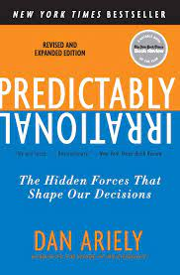

Book Name: Predictably irrational

Book Author: Dan Ariely

Genre: Psychology

Poetry Books

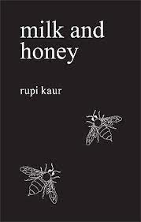

Book Name: milk and honey Book Name: These are the hands

Book Author: Rupi Kaur Book Author: Rupi Kaur

Genre: Poetry Genre: Poetry



Book Name: The sun and her flowers

Book Author: Rupi Kaur

Genre: Poetry